DAY 6 REPORT – MODEL EVALUATION

Title: Brain Tumor Detection using Deep Learning

1. Objective
The objective of Day 6 is to evaluate the performance of trained models using multiple evaluation metrics such as Accuracy, Precision, Recall, F1 Score, and Confusion Matrix to ensure reliable performance for medical diagnosis.

2. Evaluation Overview
In this stage, model performance is analyzed beyond accuracy. Since this is a medical dataset, relying only on accuracy can be misleading. Therefore, additional metrics are used to better understand model behavior.

3. Evaluation Metrics Used
The following metrics were used:
- Accuracy → Overall correctness
- Precision → How many predicted tumors are correct
- Recall → How many actual tumors are detected
- F1 Score → Balance between precision and recall
- Confusion Matrix → Detailed prediction breakdown

4. Importance of Metrics in Medical Data
- High Recall is critical → Avoid missing tumors (false negatives)
- Precision ensures fewer false alarms
- F1-score balances both
Accuracy alone is not sufficient for medical diagnosis.

5. Prediction Generation
Predictions were generated on the test dataset:
y_pred = model.predict(test_gen)
y_pred = (y_pred > 0.5).astype(int)
y_true = y_test

6. Classification Report
A classification report was generated to evaluate precision, recall, and F1-score.
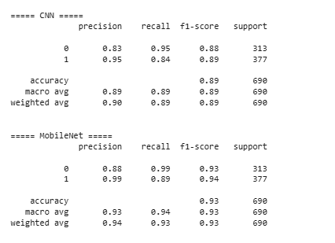
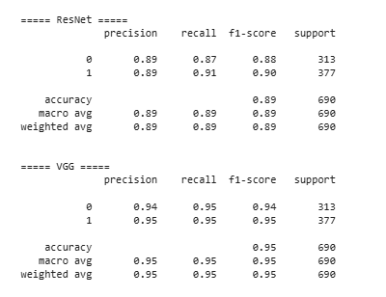
Figure: Classification Report (Precision, Recall, F1 Score)

7. Confusion Matrix
The confusion matrix shows detailed prediction results.
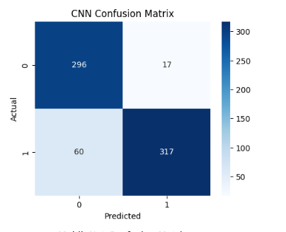
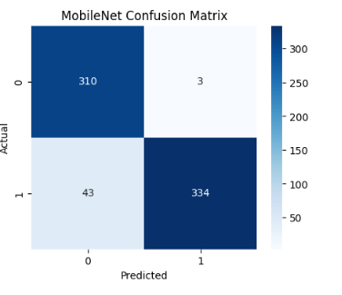
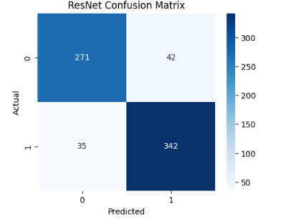
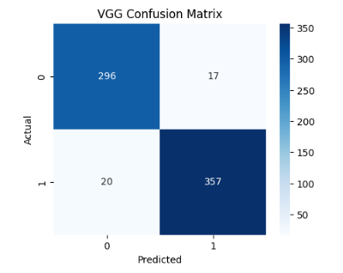
Figure: Confusion Matrix of Best Model

8. Model Comparison (Evaluation Metrics)
All models were evaluated and compared using accuracy.
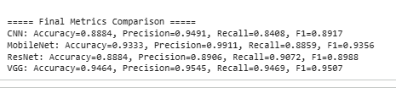
Figure: Model Accuracy Comparison

9. Result Summary
- CNN Accuracy: 88%
- MobileNet Accuracy: 93%
- ResNet Accuracy: 88%
- VGG Accuracy: 94%
Best Model: VGG (Highest Accuracy & Balanced Metrics)

10. Key Insights
- Transfer learning models outperform baseline CNN
- VGG achieved highest performance
- Recall is high → good tumor detection capability
- Confusion matrix shows low false negatives

11. Challenges Identified
- Accuracy alone was misleading
- Needed multiple metrics for proper evaluation
- Class imbalance affects results

12. Conclusion
Evaluation using multiple metrics provided a better understanding of model performance. The selected model demonstrates strong capability in detecting brain tumors with high reliability.

13. Next Step
In Day 7, model performance will be improved using:
- Hyperparameter tuning
- Regularization (Dropout, BatchNorm)
- Learning rate optimization

STORYBOARD
- Input: Test dataset
- Prediction: Model outputs
- Metrics: Precision, Recall, F1
- Visualization: Confusion Matrix
- Comparison: All models
- Output: Best model selection

DAILY TASK REPORT

What I did today:
- Evaluated models using multiple metrics
- Generated classification report
- Plotted confusion matrix
- Compared all models
- Selected best model

What I will do next:
- Improve model performance
- Apply tuning techniques
- Save best model

Issues:
- Accuracy alone was insufficient
- Required deeper analysis using multiple metrics

